# Experiment - 1

***Aim:*** A 3- ø, 230 V, 50 Hz is connected to a 3- ø load of 10kW, 0.9pf lagging. Calculate line current and line voltage for

1. When supply is star connected and load is also star connected
2. When supply is star connected and load is delta connected
3. When supply is delta connected and load is star connected
4. When supply is delta connected and load is also delta connected

***Code/Model Parameters:***

|  |  |
| --- | --- |
| **Parameters** | **Values** |
| Voltage | 220 V |
| Frequency | 50 Hz |
| Load | 10 kW |
| Load Power Factor | 0.9 lagging |

***MATLAB Code (.m file): Star Star Connection***

### Syntax

clear; clc;

close all;

Vph = input("Enter source side phase voltage(star, in volts) : "); P = input("Enter power consumed on load side(star, in watts) : "); pf = input("Enter power factor : ");

Vline = Vph*sqrt(3);

Pph = P/3;

Iph = Pph/(Vph*pf);

fprintf('\nLine current is : %0.3f',Iph); %in star, line and phase current are equal

fprintf('\nLine voltage is : %0.3f',Vline);

fprintf('\nPhase voltage is : %0.3f',Vph);

fprintf('\nPhase curent is : %0.3f',Iph);

### Results

Enter source side phase voltage(star, in volts) : 230

Enter power consumed on load side(star, in watts) : 10000

Enter power factor : 0.9

Line current is : 16.103

Line voltage is : 398.372

Phase voltage is : 230.000

Phase curent is : 16.103

## MATLAB Model (.mdl file): Star Star Connection

**Diagram of model**

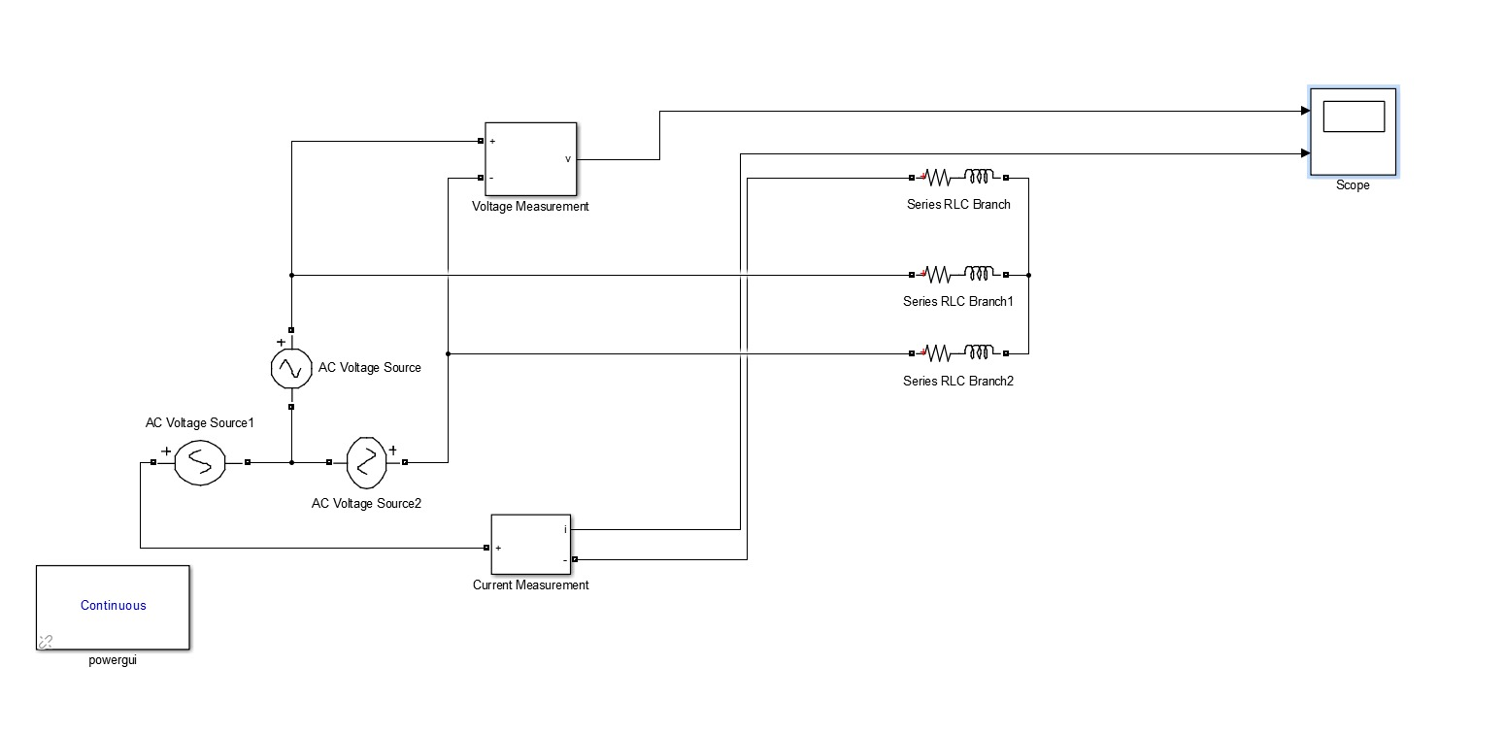

**Results**

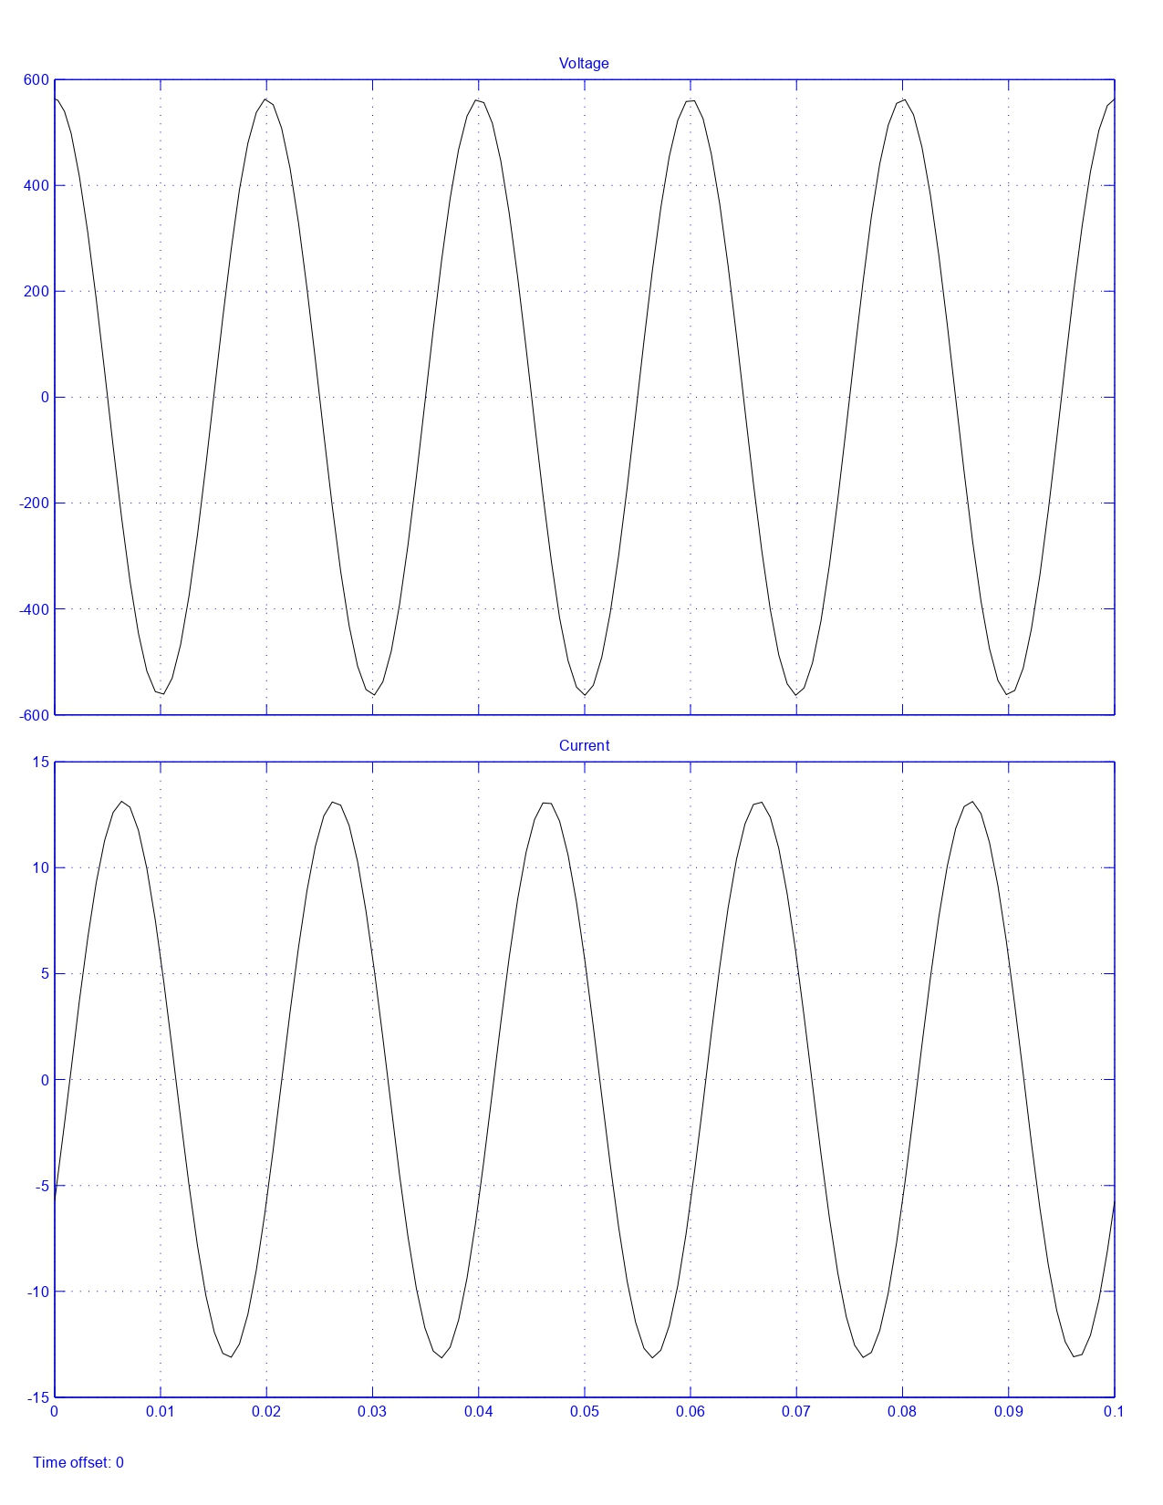

## MATLAB Code (.M file): Star Delta Connection

### Syntax

clear; clc;

close all;

Vph = input("Enter source side phase voltage(star, in volts) : ");

P = input("Enter power consumed on load side(delta, in watts) : ");

pf = input("Enter power factor : ");

Pph = P/3;

Iph = Pph/(Vph*pf);

Iline=Iph*sqrt(3);

fprintf('\nLine current is : %0.3f',Iline);

fprintf('\nLine voltage is : %0.3f',Vph);

fprintf('\nPhase voltage is : %0.3f',Vph);

fprintf('\nPhase curent is : %0.3f',Iph);

### Results

Enter source side phase voltage(star, in volts) : 230

Enter power consumed on load side(delta, in watts) : 10000

Enter power factor : 0.9

Line current is : 27.891  
Line voltage is : 230.000  
Phase voltage is : 230.000  
Phase curent is : 16.103

## MATLAB Model (.mdl file): Star Delta Connection

### Diagram of model

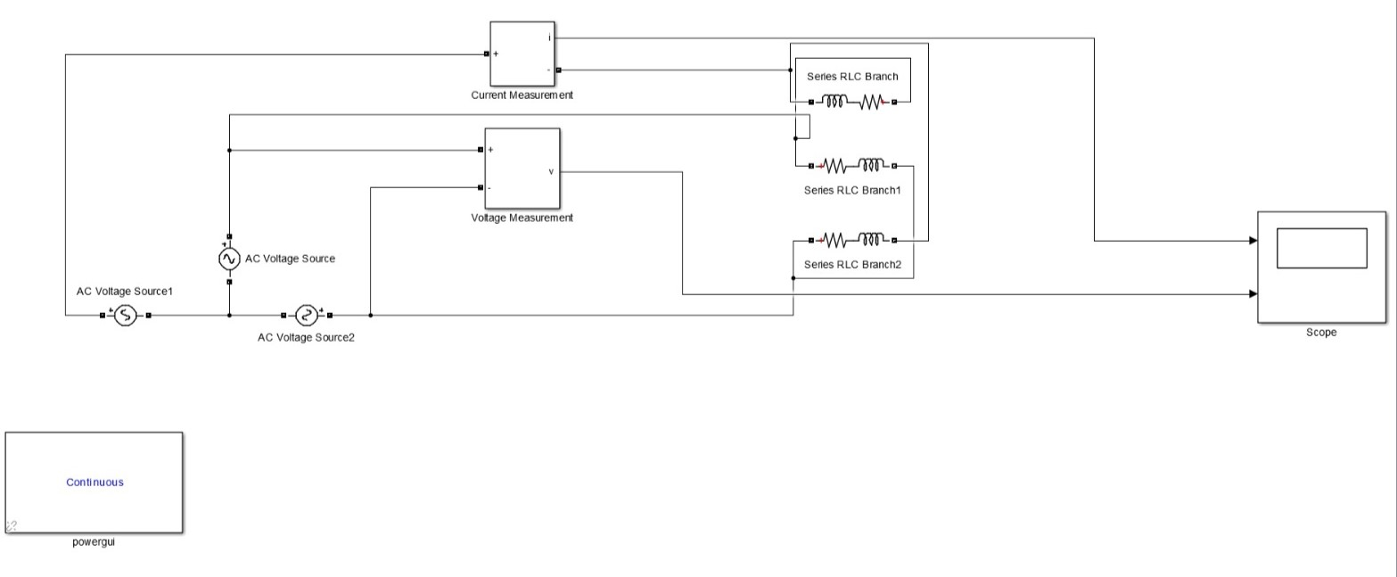

**Results**

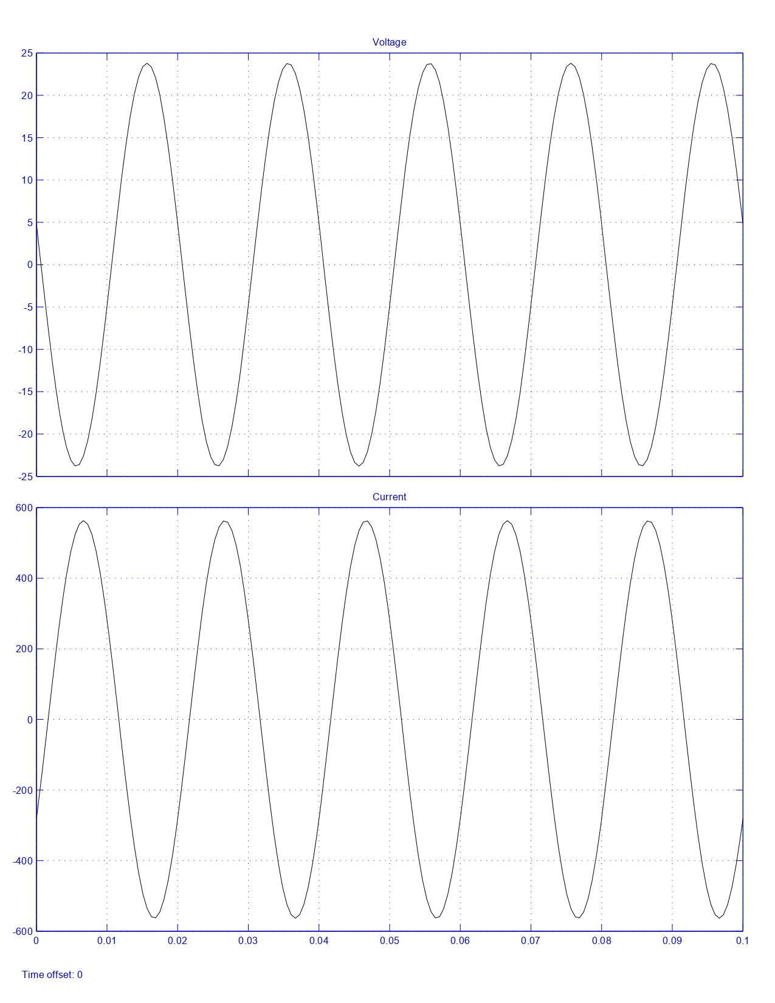

# Experiment - 2

***Aim:*** What is the percentage saving in feeder copper if the line voltage in a 2-wire d.c. system is raised from 200 volts to 400 volts for the same power transmitted over the same distance and having the same power loss?

***Code/Model Parameters:***

|  |  |
| --- | --- |
| **Parameters** | **Values** |
| Initial Voltage | 200 V |
| Final Voltage | 400 V |

***MATLAB Code (.m file)***

### Syntax

clear; clc;

a = input('Initial Voltage : ');

b = input('New Voltage : ');

s = (1-(a/b)^2)*100; fprintf('Savings is : %0.2f',s);

### Results

Initial Voltage : 200 New Voltage : 400 Savings is : 75.00

## MATLAB Model (.mdl file)

**Diagram of model**

# 